Friends Meeting of Washington (FMW)
Report of the Religious Education Committee for January-June 2014
Presented at theJune Meeting for Worship with a Concern for Business

Committee members: Kim Acquaviva (Clerk), Rob Farr (Recording Clerk), Jane Connor, Anita Drever, Nicole Else-Quest, Carrie Mitchell, Windy Cooler (Youth Program Coordinator and ex officiocommittee member)

The Religious Education committee cares deeply for the spiritual lives of the children in our Meeting and we rejoice in how much they bring life and Spirit to our Meeting. FDS and youth programs at Friends Meeting of Washington havecontinued to grow and deepenin the six months since our last report, thanks to the ongoing commitment of our community. The following describes our progress and programming during the period from January 2014 through June 2014:

Nursery – Head of Nursery: Makai Kellogg
The Meeting offers child care to our littlest attenders – those from birth through 4 years of age -each week during 10:30 Meeting for Worship as well as during the monthly Meeting for Worship with a Concern for Business. Our nursery continues to serve a growing body of Quaker families and visitors to FMW, necessitating the promotion of our long-time nursery worker Makai Kellogg to the position of Head of Nursery. Makai supervises all staff in the nursery and will be working closely with the Child Safety Committee to ensure the hygiene and physical safety of the nursery environment in addition to welcoming families in the sensitive and warm manner we have become accustomed to. Our nursery is well staffed a rotating team of paid caregivers (including our beloved Katorra who has been with us for many years) providing care to a growing number of young children in the Meeting.We continue to provide skilledchildcare for special events at FMW and are grateful to the Meeting for approving the larger Religious Education budget last year that has made this possible.

Lower Elementary – Coordinator: Jay Harris
The Lower Elementary (LE) class at First Day School supports the religious education of children ages 4 to 6 years old. This class has seen strong support and attendance by children of FMW members and attenders, as well as parents of School for Friends. On average, there are five children each First Day. The LE class has a dedicated group of parents who volunteer to lead the class; special thanks to Anita Drever, Robin Appleberry, Nicole Else-Quest, and Jay Harris. Other volunteer leads join the class as their schedule permits. There are always two teachers - the lead and their support – for each class.

Upper Elementary – Coordinator: Michael Beer
The Upper Elementary (UE) class supports the religious education of children ages 7 to 11 years old. UE children continue to visit the Church of the Pilgrims monthly to make sandwiches for the homeless. The first Sunday of every month, all children and parents join together in a “Family Meeting for Worship.” There are always two adult leads/teachers for every First Day, and we continue to have a large number of volunteers who help make the UE class a dynamic and Spirit-filled learning community for our youth.

Overview of Programming in Lower and Upper Elementary Classes
Our two elementary classrooms (lower elementary and upper elementary) have had many special guests this year, learning about Quaker history and philosophy as well as themes like inward looking, social concerns, and just having fun. Our special guests are Friends not involved in regular classroom instruction who have a special talent or topic they would like to share. We've made "zines", planted a garden, read books, played games, held a (loud!) drumming circle with pots and spoons in the park, andlearned about Right Sharing of World Resources. Our youth benefited greatly from the knowledge, experience, and passionshared by our special guests, and we are deeply appreciative of the gifts of time, talent, and Spirit each of them shared with our youth.
The two elementary classes, while still distinct, have had several classroom experiences with one another as we cross bridges, exploring what we might be able to do with people our own age and what we might be able to do with people older and younger. Our youth continue to learn about how to care for the building we share with so many other Friends, making a paper "fire" for Thanksgiving, decorating the windows for our Spring Simple Meal with School for Friends, and daydreaming about new ways to play in the gardens that surround us.

Junior Young Friends/Tweens &Teens – Coordinator: Kim Acquaviva
The past 6 months have been vibrant ones for the youth in the Junior Young Friends group (AKA “Tweens and Teens.”) The Tweens & Teens launched “The Quaker Ukulele Collective” earlier this spring, beginning a tradition of chaotically melodious, Spirit-filled jam sessions each First Day in the third-floor room where we meet. Although there are always two or more adults present, the Quaker Ukulele Collective is essentially a leaderless initiative of the tweens and teens. A big part of the fun of the Collective is that it’s totally unlike a structured music lesson. There are no “teachers” – just ukuleles, a stack of songbooks, a few pictures showing ukulele chords, and two or more “Friendly Adult Volunteers” (AKA “FAVe’s”) who sit quietly in the room as a resource the tweens & teens can choose to engage with (or not). Learning is experiential, with the tweens & teens figuring out chords, trying out different ways to strum, and teaching one another new skills as they figure them out themselves. It’s been a joy to watch the tweens and teens work collaboratively to experience the creation of music in a wholly unstructured and joy-filled way.
The Tweens & Teens have several people they would like to thank and recognize. First, they give particular thanks to Emilie Schmeidler and Ken Orvis - two steadfast volunteers who have given their time, energy, and enthusiasm to the group throughout the year. Emilie and Ken embody the very kindness, patience, enthusiasm, and unconditional love we hope our tweens & teens will come to emulate. The Tweens & Tweens Group would also like to acknowledge the following Friends who donated ukuleles to the Collective:Sally Hill Cooper, Haverford Friends Meeting; The Connor-Olabi Family, FMW; The Avanesyan Family, FMW; Bertrand (“Bertie”) Rossert, FMW; Dan Dozier & Martha Solt, FMW; and The Acquaviva-Brandt Family, FMW. Individual tweens & teens became the designated "teen uke steward" for a ukulele that had been donated to the Collective. Each of the Collective's ukuleles have a colorful tag attached to the case (see pic below), acknowledging the name of the donor and the name of the "teen uke steward" playing and caring for that ukulele.
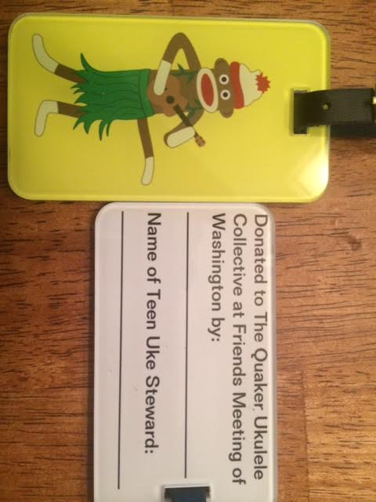
The Tweens & Teens held a fundraiser to benefit Friends Meeting of Washington and sold 75 “Quaker Ukulele Collective” t-shirts (see pics above), raisinga total of $306.02. This fundraiser ended up having an unintended side benefit: generating intergenerational excitement about the tweens’ & teens’ ukulele-playing efforts. The love and support shown by the FMW community to the tweens & teens is a big part of why they didn’t hesitate to follow their leading to play a song for Friends after Meeting for Worship on June 1st – a song they had just taught each other about 20 minutes earlier. There’s something magical about watching teens teach, support, and encourage one another (“Just play the one chord you know and you’ll do great!”).
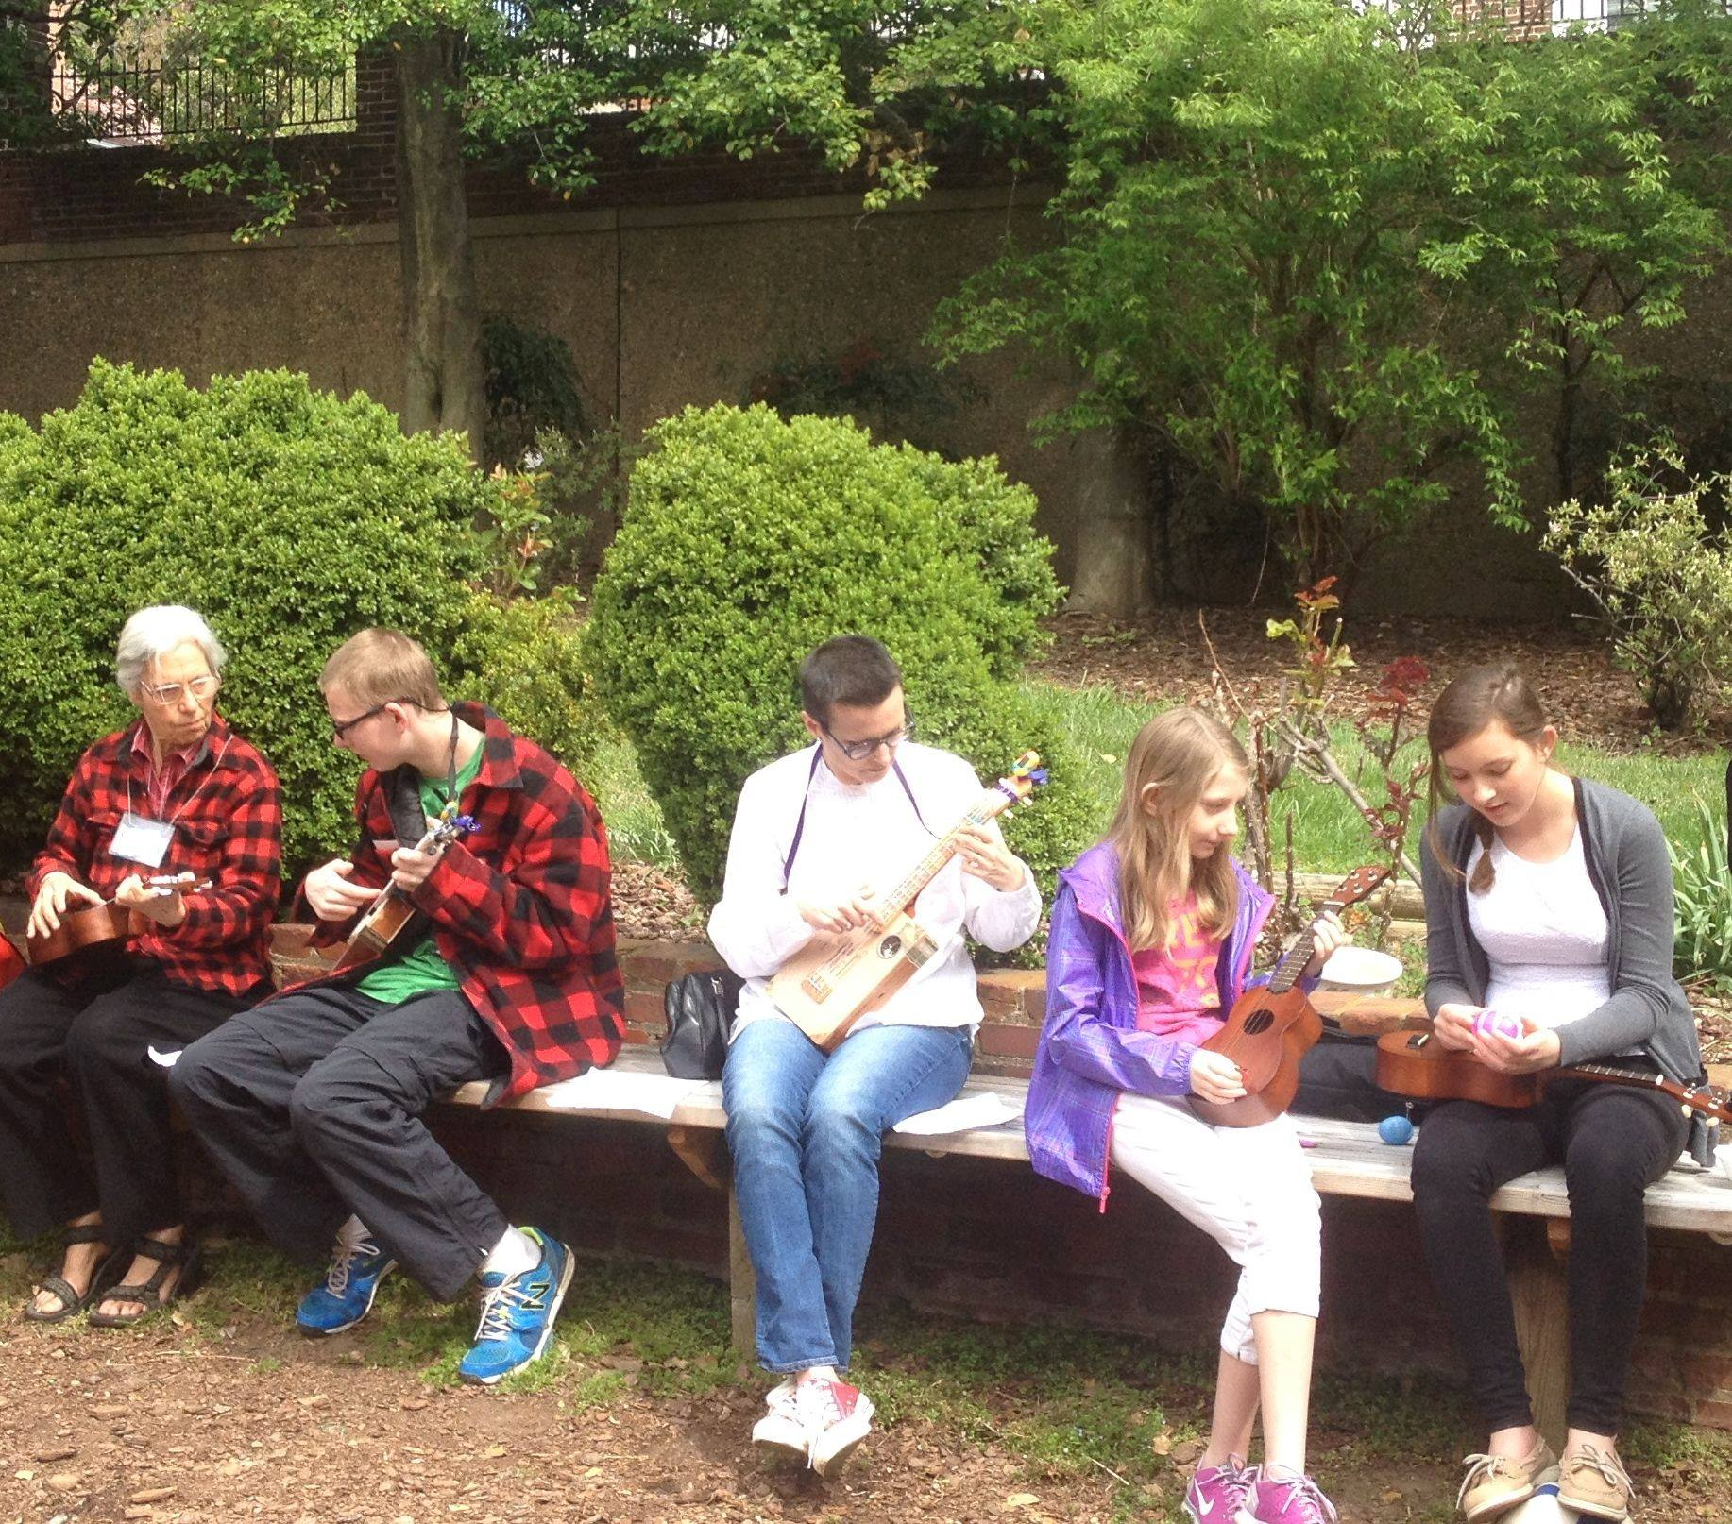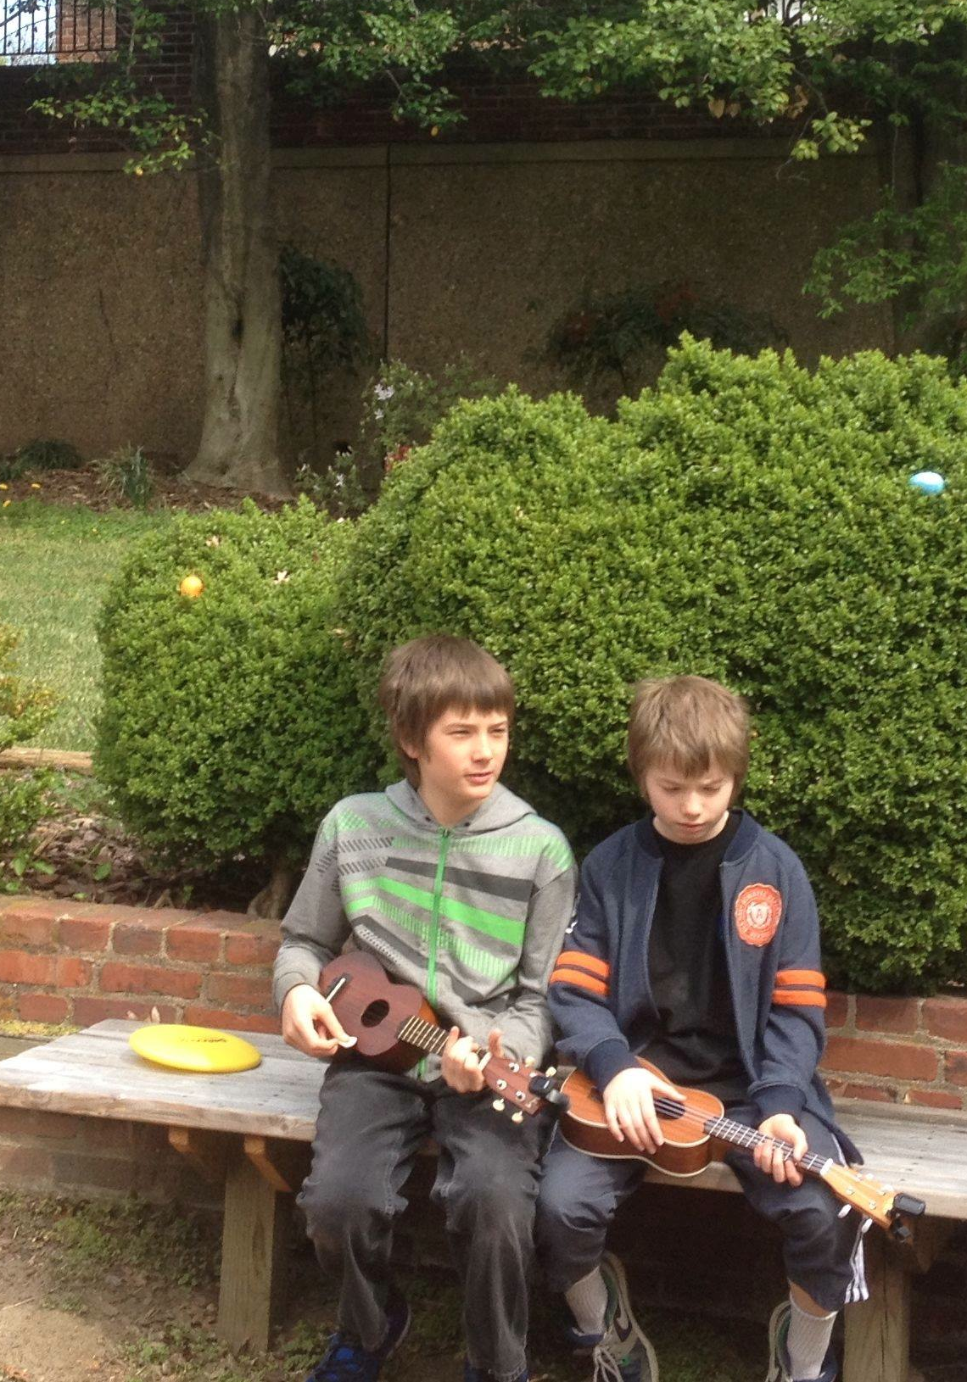
In the Fall, the Tweens & Teens “Quaker Ukulele Collective” will continue meeting weekly. We’re going to experiment with a 10-minute “Donuts and Dialog” period at the start of each session to see if this will increase discussion and cut down on the amount of donut dust coating our ukes.

Baltimore Yearly Meeting
Our Yearly Meeting(BYM) continues to have a very active youth program that includes regular weekend retreats at Monthly Meetings throughout BYM for those in 6th through 8th grade – Junior Young Friends –(see http://jyf.bym-rsf.net) and those aged 14-20–Young Friends –(see: http://yf.bym-rsf.net/). Parents of FMW teens report to us that the BYM programs are just wonderful and enable the teens to get to know other younger Friends from all over the area and they have the time of their lives together while practicing lived Quakerism through the regular retreats they have. The next gathering for both Young Friends and Junior Young Friends is Annual Session (http://www.bym-rsf.org/events/annualsession/ashome.html) It takes place from August 5th-10th at Frostburg State University. Rising 6-8th graders stay in dorm rooms with their parents, but gather throughout each day for various activities. Rising 9th graders have the choice of participating in the middle school program or the high school program. Rising 10-12th graders and FAPs stay in rooms all on the same floor, and build a lived community like a conference. If they are 18 years old, high school graduates have the choice of participating in the high school program, or the Young Adult Program (18-35 years old). Register online at https://bym-rsforg.presencehost.net/events/annualsession/registration.html before June 23rd for the lowest rates. Friends may contact Alison Duncan, BYM Youth Programs Manager, at youthprograms@bym-rsf.org for more information.

Adult Religious Education Study Group – Coordinated by John Scales
During the past six months the study group met generally once or twice a month on Sundays before the Meeting for Worship. It benefitted by the contributions of new, as well as long-standing members, as they shared in their readings and led discussions.
Over more than a decade of its meetings, it has considered a wide range of topics of interests chosen to enhance appreciation of contributions Quakers and others make to individual spiritual growth and society. Sessions over the years have addressed Quaker history and Quaker leaders (e.g. George Fox, John Woolman), Social activists with Quaker backgrounds (e.g Lucretia Mott, Susan B. Anthony, Bayard Rustin), writers with Quaker influences (e.g., James Michener, Thornton Wilder, Walt Whitman). Religions such as Hinduism, Judaism and Buddhism, have been considered in terms of their tenets and differences and similarities to Quaker beliefs and approaches. Movements in which Quakers have been very involved, for example the Underground Railroad and Peace Testimony have been featured. Writers about spirituality from other religions and contemporary issues are also considered.
Since last Fall, the group considered a number of different subjects and sources, led by members of the group and guests, including:
- Patrick Lynam on Howard Kushner’s book: "When Bad Things Happen to Good People", based partially on the Book of Job. Kushner was a rabbi in a large congregation. He knew first-hand about family disasters such as: death, disease, job loss, divorce. Kushner’s aim is to avoid being like “Job’s counselors” by giving thoughtless advice to people in crisis.

- Blair Forlaw on “Friends and Neighbors Building a Sustainable Peacein Rwanda.” with a guest speaker, Theoneste Bizimana, coordinator of AGLI’s Healing and Rebuilding Our Communities Program in Rwanda (HROC). A response to the awful and lasting devastation of the 1994 genocide, HROC workshops bring perpetrators and survivors together in a shared experience to acknowledge and grapple with the events and consequences of the violence, restore trust, rebuild communities that were torn apart – physically, socially, economically, and emotionally. HROC is a centerpiece of several programs sponsored by the African Great Lakes Initiative to promote a sustainable peace in Rwanda, Burundi, Kenya, Uganda, and the Democratic Republic of the Congo.

- Blair Forlaw, Molly Tully and John Scales regarding the history of Quakers in Virginia and Maryland (particularly the Eastern Shore).

- Rob Callard, presenting wonderful Christmas Story he wrote himself.

- Patrick Lynam, the Atheist Delusions: The Christian Revolution and Its Fashionable Enemies, an entertaining and informative polemic directed against the spate of atheistic bestsellers (and some older works) denouncing Christianity including: Christopher Hitchens’ God is Not Great: How Religion Poisons Everything Ideal.

Ongoing Child Safety Discussions
We feel much gratitude in our hearts to those in our FMW community who are working to translate our shared commitments and hopes into a brief and actionable safety and welcoming policy for the Meeting. The foundational work for this effort was ably led by Marsha Holliday and the Child Safety Committee, leading to the ultimate approval of a Child Safety Policy by FMW’s Meeting for Worship with a Concern for Business in 2013. As members of the RE Committee, we hold in the Light the ad hoc group that hasnow formed to endeavor to explore ways to know the people who worship with us, and in the case of those who may be perceived as a threat to the community, understand their situations well enough to manage possible dangers while understanding our own fears and concerns so as to remain open and welcoming.Clerked by Meg Greene, Dan Dozier, Shannon Zimmerman and Gray Handley, the ad hoc group is composed of members from multiple committees and stakeholder groups at FMW, including from RE and the parent community. We feel fortunate to be part of a Meeting community in which difficult issues like this are explored, discussed, wrestled with, and prayerfully considered. Rough seas make for skillful sailors and, in the case of our Meeting community, a boat filled with sailors committed to working together to weather whatever storms come our way.

Appreciation for Windy Cooler, Your Programs Coordinator
When the Religious Education Committee selected and hired Windy Cooler, our Youth Program Coordinator, we saw an almost immediate transformation of the quality and organization of our youth programs From her first days with us, Windy has made a significant impact on our Meeting, on our children, and on our hearts. The energy, positive spirit, and joy which Windy brought to FMW’s Youth Programs has been transformational, and both our nursery and First Day School programs are thriving thanks to her Spirit-filled leadership and coordination.
Windy will be leaving FMW at the end of August to begin her studies at Wesley Theological Seminary, a departure than brings both feelings of sadness and feelings of joy. We are sad to lose such a dynamic Youth Programs Coordinator, but our hearts sign with joy knowing that Windy is embarking on the next step of her personal spiritual journey. Windy will continue being a part of developing solid RE programs in her role as a BYM RE Committee member (along with Marsha Holliday and Mark Cannon), so we can look forward to her continued contributions to youth programming. We are grateful to Windy for all that she has done for the children of FMW and we wish her both luck and blessings on her journey.

Summer Plans for the Transition
This summer, FMW will offer nursery care and for the elementary grades, supervised playtime. Windy will continue to work with Makai over the summer to ensure there is staffing each week to cover these commitments. Before she leaves in mid- to late- August, Windy has let us know that she will be working with the appropriate committees to fully implement our new child safety policy; addressing issues of space maintenance; and helping to bring our teenagers into the meeting in adulthood, among other things. The RE Committee willadvertise the Youth Programs Coordinator position this summer, with the goal of having a person hired and in place before FDS starts up again in the Fall.

Conclusion
The Religious Education Committee is excited about the progress and programming in FMW’s youth programs over the past 6 months, and we look forward to another vibrant year of religious education. We remain grateful to the Meeting for its generous financial support of our nursery, First Day School, and staffing. Thank you to all who have made our programs a success in 2014!

